**SCD: DimProductCost : 27060 rows**

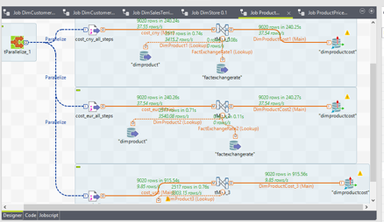

**SCD:DimProductPrice : 29082 rows**

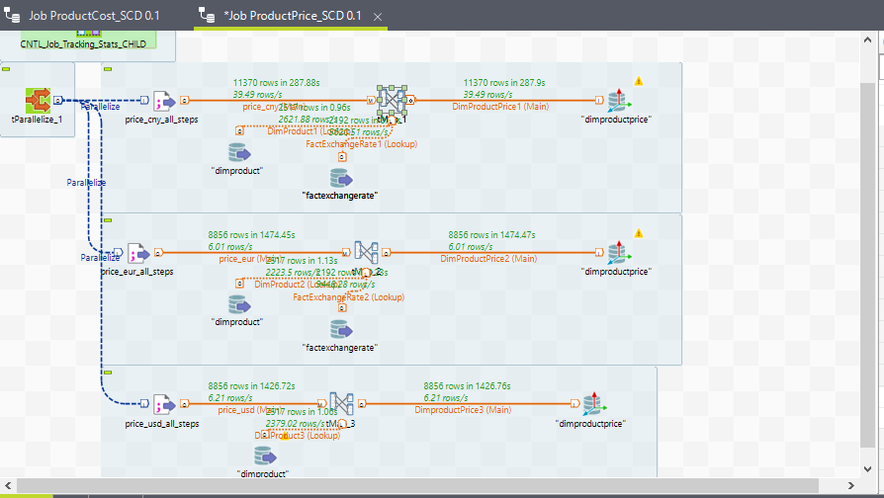

**DimAccount : 24 rows**

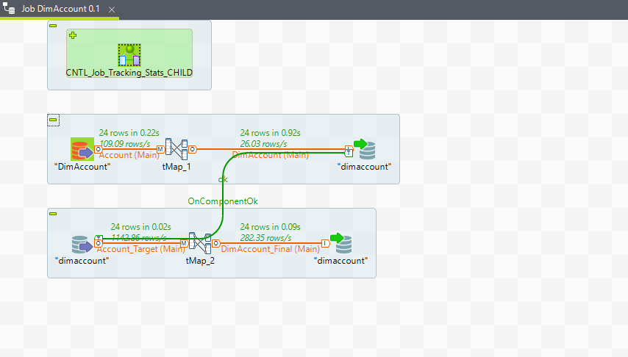

**DimChannel : 4 rows**

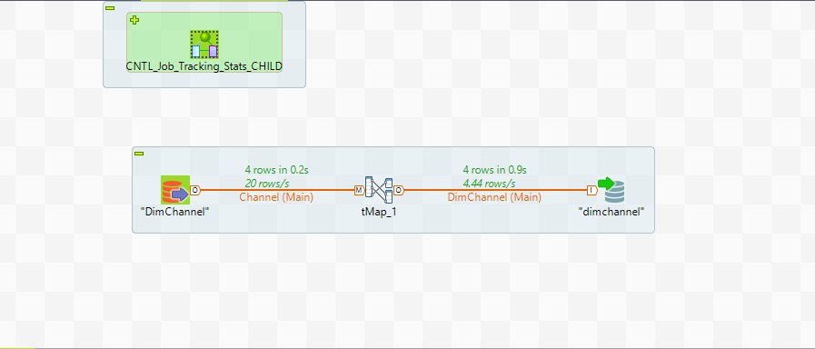

**DimCurrency : 28rows**

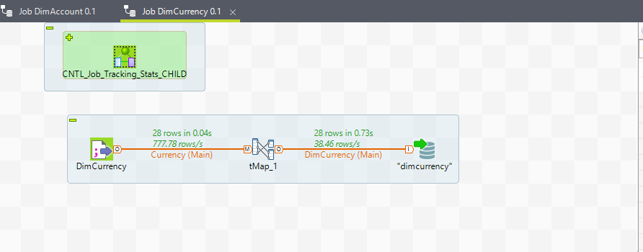

**DimCustomerCompany : 385 rows**

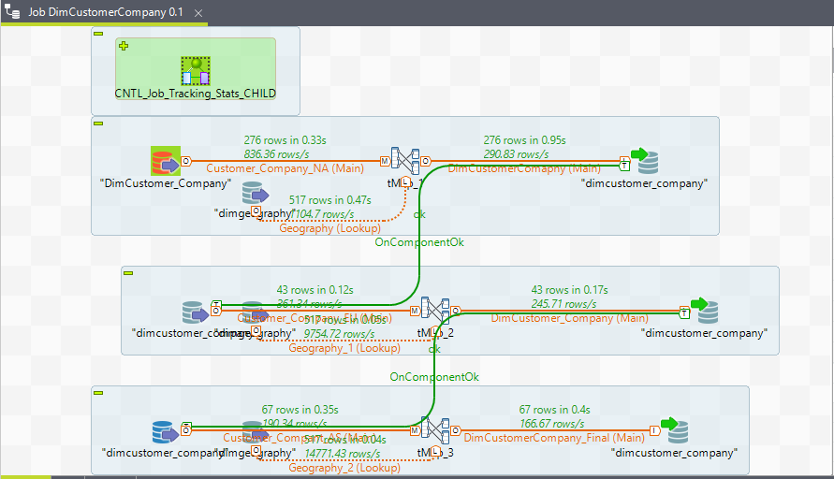

**DimCustomerPerson : 9097 rows**

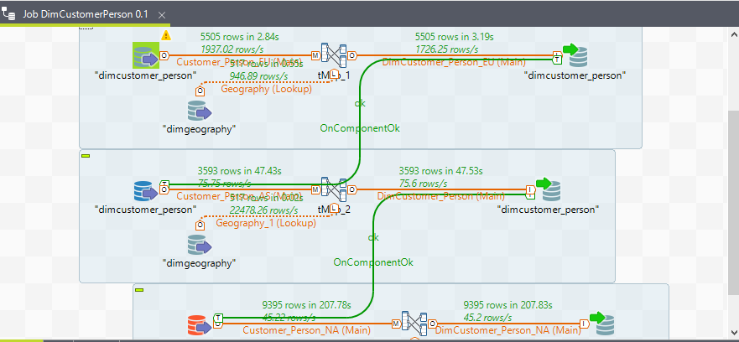

**DimDate : 45656 rows**

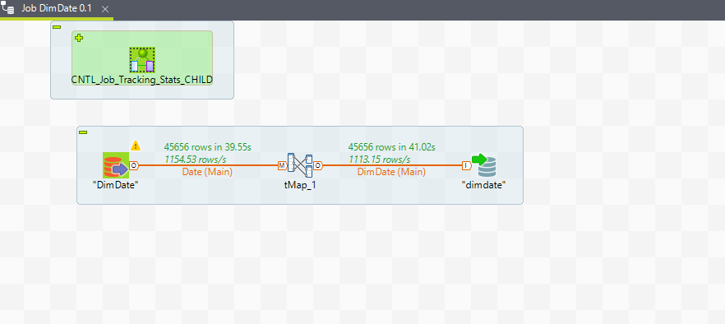

**DimEmployee: 293 rows**

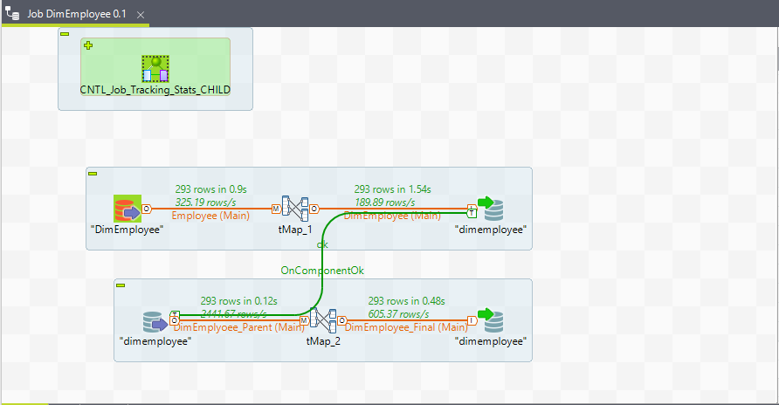

**DimEntity : 421 rows**

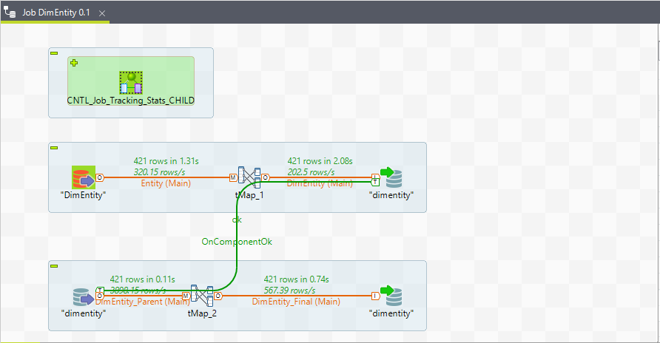

**DimGeography : 517 rows**

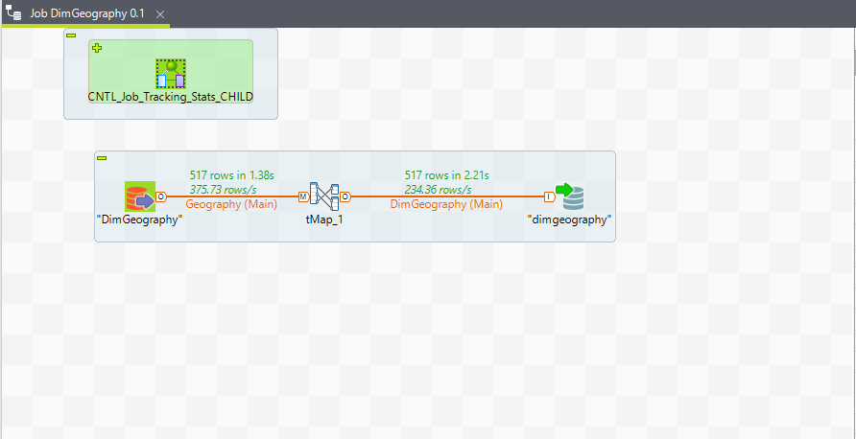

**DimProduct : 2517 rows**

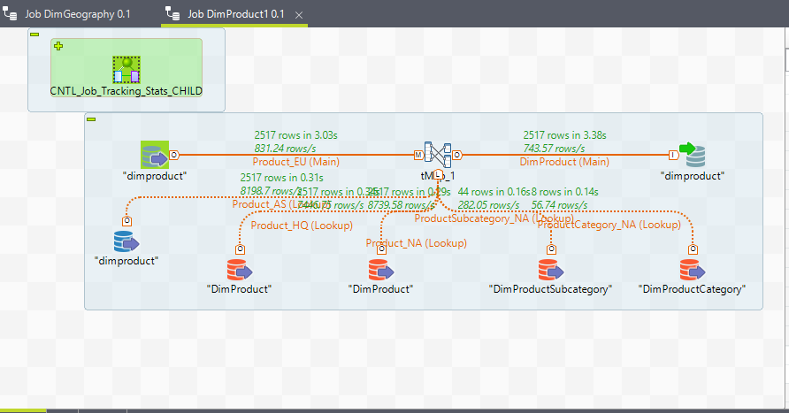

**DimPromotion : 28 rows**

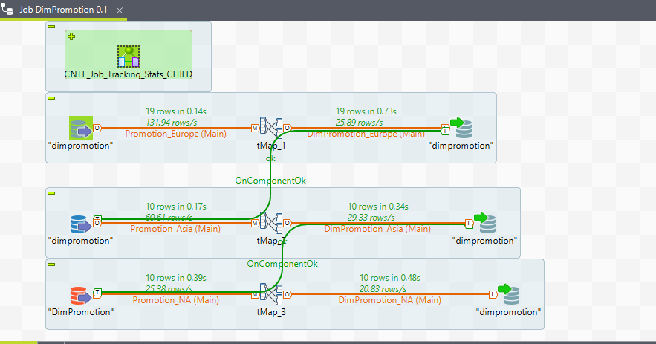

**DimSalesTerritory : 82 rows**

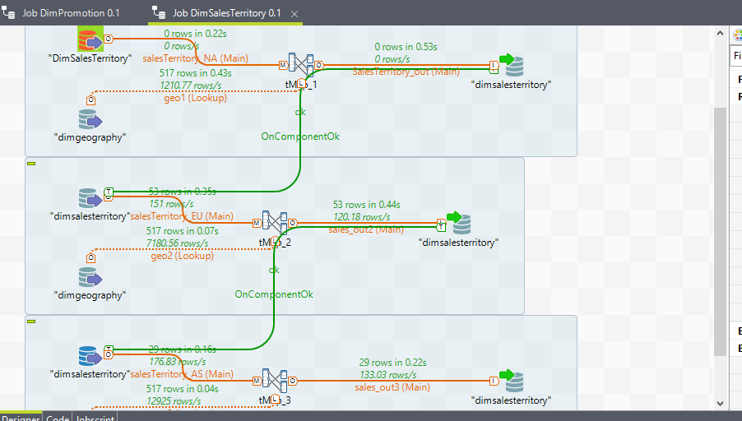

**DimScenario : 3 rows**

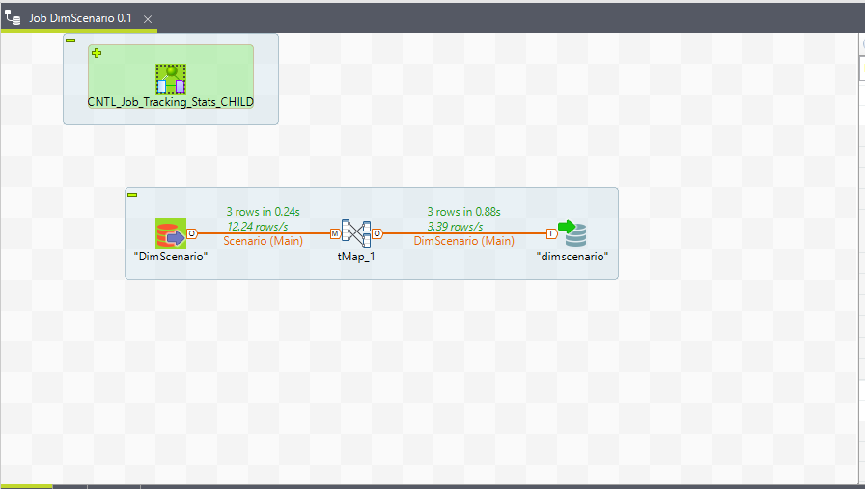

**DimStore : 306 rows**

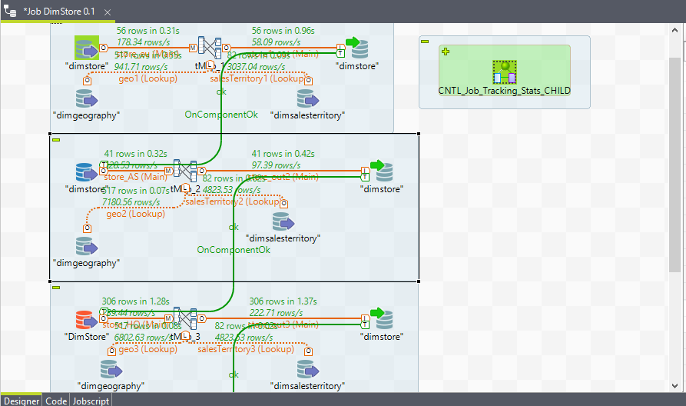

**FactExchangeRate: 2192 rows**

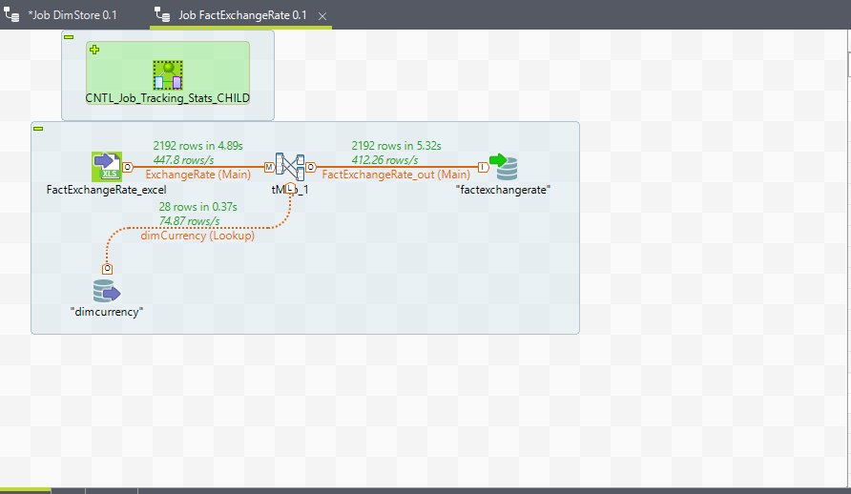

**FactInventory : 8013099 rows**

**FactInventory_Rejects : 0 rows**

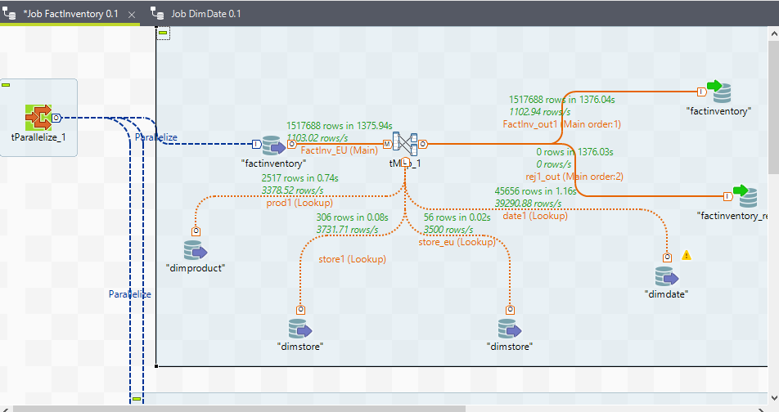

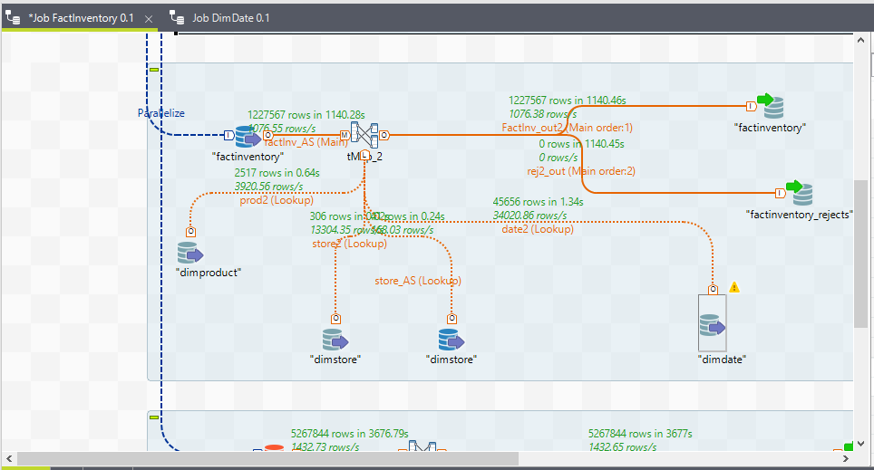

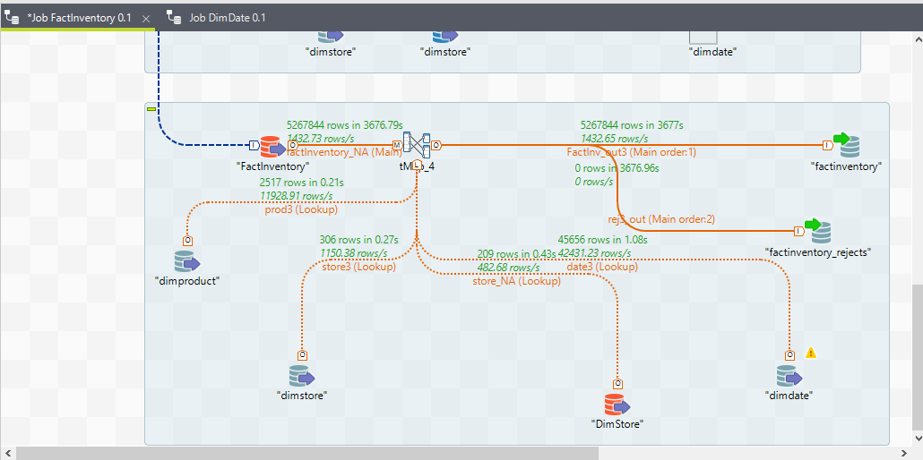

**FactOnlineSales :**

**Asia: 4216671 rows**

**Asia-Rejects : 578897 rows**

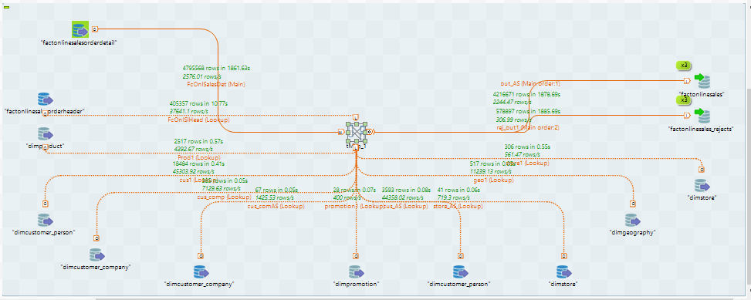

**Europe: 3924080 rows**

**Europe-Rejects : 538292 rows**

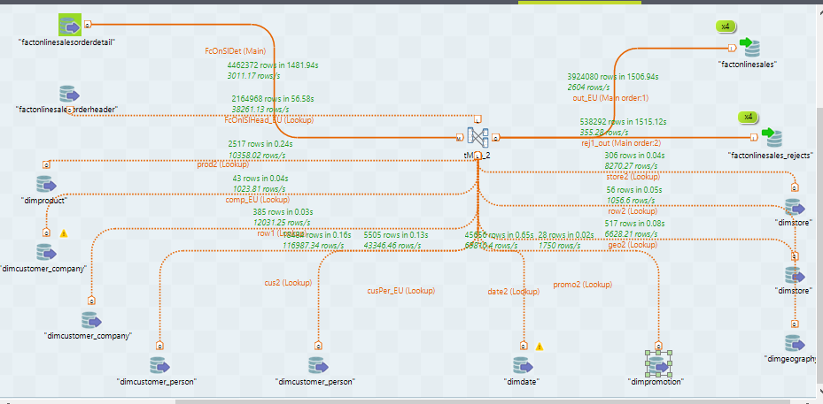

**North America : 4785013 rows**

**North America-Rejects : 742222 rows**

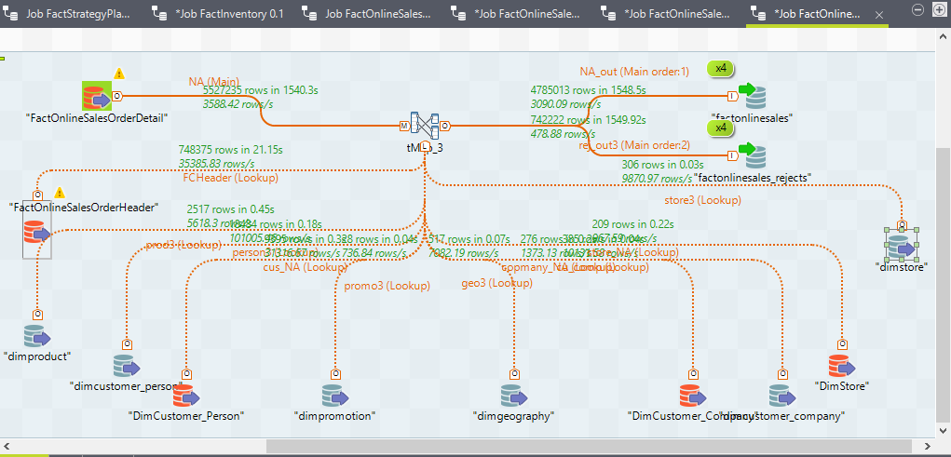

**FactSalesQuota : 4977274 rows**

**FactSalesQuota_Rejects: 0 rows**

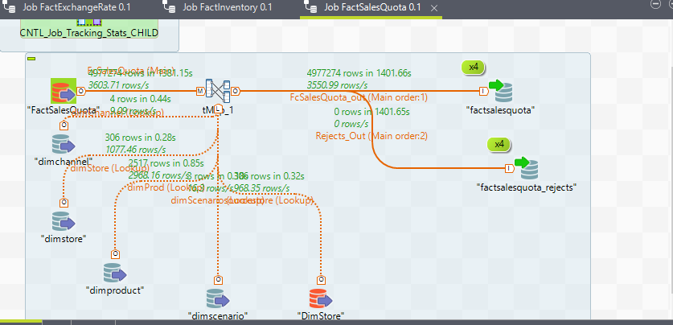

**FactStrategyPlan: 1833752 rows**

**FactStrategyPlan_Rejects: 0 rows**

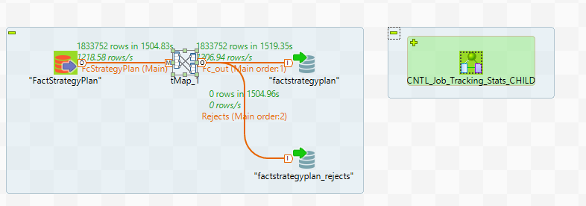

**FactSales: rows**

**FactSales_Rejects: rows**

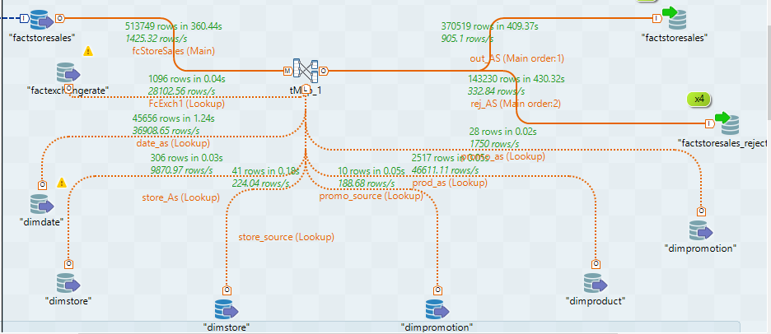

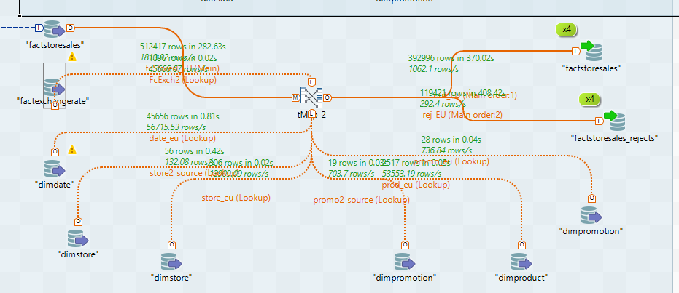

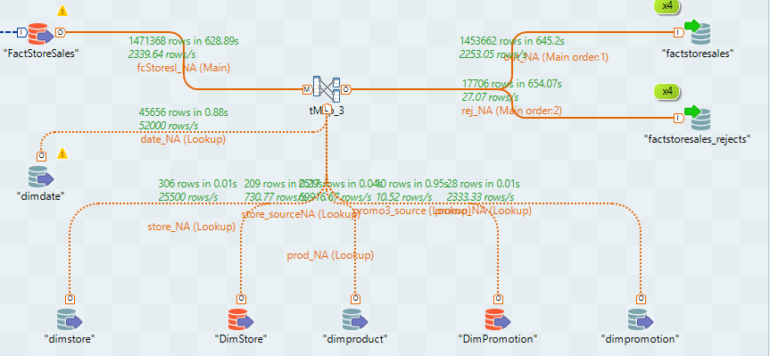

**FactCatalogSales: 194976rows**

**FactCatalogSales-Rejects: 25261 rows**

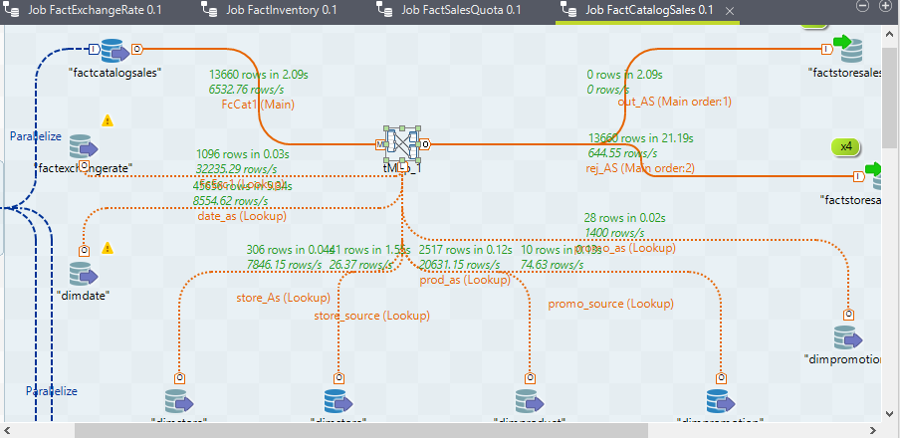

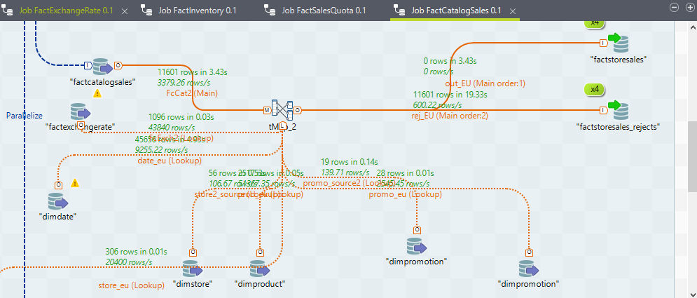

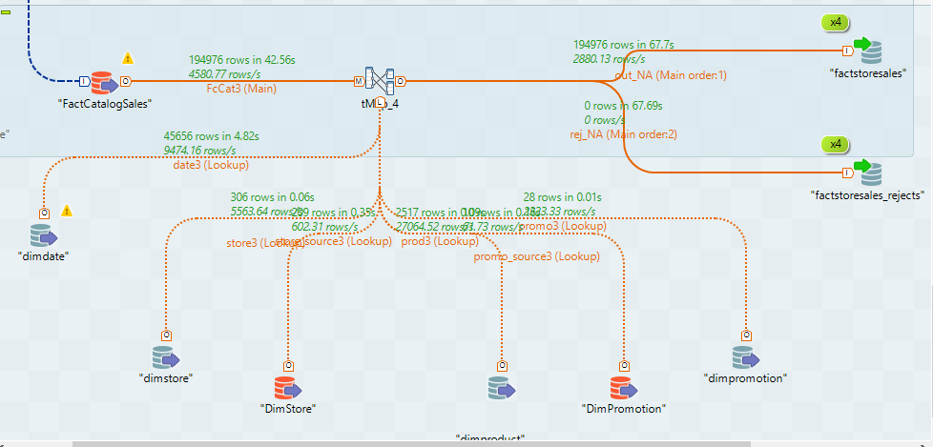

**FactResellerSales: rows**

**FactResellerSales-Rejects: rows**

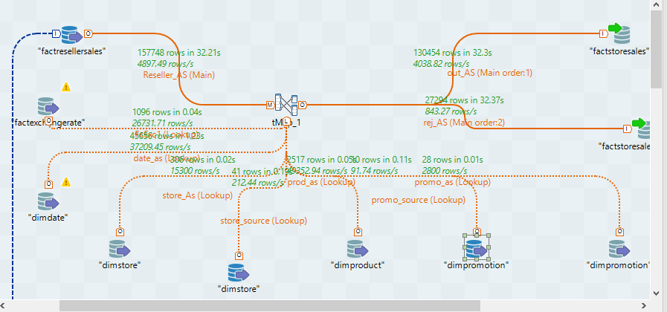

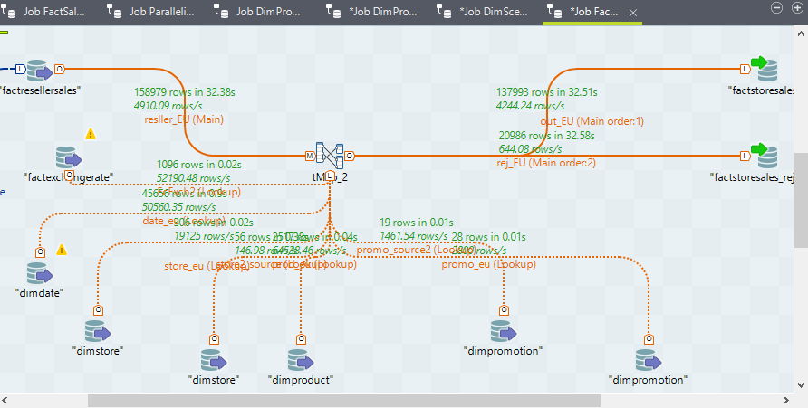

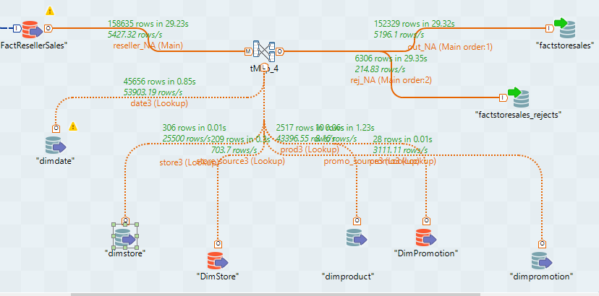

**Total:**

**FactStoreSales: rows**

**FactStoreSales-Rejects: rows**

**Parallelised Dimensions:**

